Festival of Muslim Cultures, World Sufi Festival & Riverside Studios present

Ajoka Theatre Company’s BULHA  Urdu and Punjabi with English surtitles  Directed by Madeeha Gauhar • Written by Shahid Nadeem  1-4th August, 7.45pm  Riverside Studios, Crisp Road, Hammersmith, London W6. www.riversidestudios.co.uk  £20 (£14 concessions)  Groups 10+ £17.50  Groups 50+ £15  Box Office: 020 8237 1111 | 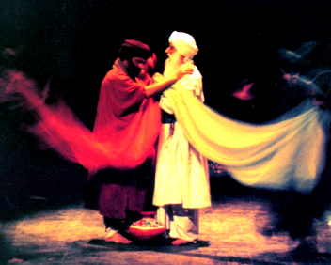

‘If you have understood the Truth, why fight over the names of Allah, Lord or Ram?’ Baba Bulleh Shah (1680 – 1758)

The great Punjabi Sufi mystic Bulleh Shah, affectionately called ‘Bulha’, lived in turbulent times. The mid 18th century saw the decline of the Mughal empire, with communal violence, civil wars and ideological chaos, times not very different from today. Bulha challenged the status quo by rejecting dogma and social oppression. His was a voice for humanism, peace and love, and his poetry is today recognised internationally and widely performed on the world music circuit.

Ajoka Theatre Company’s acclaimed production, BULHA is performed by a 21-strong company as a piece of musical theatre. Sufi devotional music is performed live onstage as Bulleh Shah’s poems, Kafis, are rendered by a Qawwal party of vocal performers, lead by Javed Bashir & Arif Ali. This tale of his life carries a powerful message about peace and tolerance. Performed in Punjabi & Urdu, the show celebrates the rich and vibrant culture of the Punjab. Ajoka’s critically lauded show has been seen in India, Iran and the US as well as in their native Pakistan, where Ajoka are the country’s leading non-commercial and socially committed performing arts group, presenting entertainment with a social purpose.

We thank the Ministry of Culture, Pakistan, for their support. The Festival of Muslim Cultures is a UK-wide arts and educational festival, bringing Muslim cultures into the mainstream of UK life. For more information visit www.muslimcultures.org.

For press enquiries please contact Nada Raza, Press Coordinator, Festival of Muslim Cultures at nada@muslimcultures.org  (Tel: 0794 6794 212)  or Suman Bhuchar, Ajoka Tour Producer at  sumanbhuchar@lineone.net (Tel:07930101894) | 